FACTS ABOUT ASSOCIATION LIVING AND CMA’S SERVICES

Welcome to membership in an exclusive club…Your Homeowners’ Association!

What is a Homeowner’s Association?

- It is a legal non-profit corporation registered with the State. The Association has Articles of Incorporation that entitle the Association to exercise powers of a corporation.

- The Association is “governed” and managed by a duly elected Board of Directors.

- Its purpose is to maintain all common areas and amenities and to govern the community in accordance with the governing documents.

- The corporation is financially supported by all members of the Homeowners’ Association.

Who is a member of the Homeowners’ Association?

- Includes all the people who own homes in the same development.

- Membership in the Association is mandatory and automatic for all owners. The deed to each lot specifically designates that the property owner will comply with the Covenants, Conditions, and Restrictions of the Association.

What is the purpose of Governing Documents?

Governing Documents determine the structure of your association and establish obligations and responsibilities of its members and elected officers and directors. Each owner is responsible to adhere to the provisions set forth in your governing documents. Governing Documents include:

- Articles of Incorporation
- Bylaws
- Declaration of Covenants, Conditions and Restrictions

What is the Annual Meeting and when is it?

The Annual Meeting is the yearly meeting of the members at which a summary of the year's activities is given and annual reports are distributed. Notices will be sent prior to the meeting to notify you of the time and location of the meeting.

The Bylaws outline the rules pertaining to the Board of Directors.

- There may be 3, 5 or 7 Board Members.

- Each Association has specific Bylaws outlining the process for Board elections. Generally speaking, the board elections take place on an annual basis either prior to (in the case of absentee ballots) or at the annual meeting (proxies and ballots).

- The Bylaws in your governing documents give descriptions of Director roles and the length of terms in office.

- All affairs of the Association shall be conducted by the Board of Directors or elected and/or appointed officers of the Board.
What is the role of Committees?
In general, each association will have mandatory committees such as an Architectural Committee. An Association may also have standing committees which could include finance, landscape and newsletters. Occasionally ad-hoc committees may be formed, temporarily created for specific one-time items (e.g. selection of a refuse provider).
Members of committees are appointed and removed by the Board of Directors. The primary function of the committee is to render a recommendation to the Board on the subject matter of their committee. This recommendation, once delivered to the Board of Directors, is then approved/rejected by the Board.

Who is responsible for Common Area maintenance?

The Association maintains the common property areas for the shared used and enjoyment of all owners. For example, this includes negotiating the contract for landscape maintenance, then routinely monitoring the performance to assure conformity in service and effect. Other examples of common area may include entry features, fountains, sports courts, playgrounds and pools.

Who do I contact for Customer Service?
The business of your association and the operation of its amenities are professionally managed by RTI/Community Management Associates, Inc., (CMA). The CMA team of association management professionals has a strong commitment to the associations they serve with a broad range of contract services.
CMA offers 24/7 customer service through its website, www.cmamanagement.com. Owners may log in to view their secure personal account information, access their covenant enforcement record and pay their assessments online. The site also provides a quick and easy connection for submitting and tracking requests.

The company’s Customer Care Center handles calls concerning a broad array of questions and comments from account balances, to requests for pool cards or notifications of common area issues for the managers.

The call center staff are knowledgeable and eager to serve CMA’s clients. The CMA Customer Care Center responds to calls during the hours of 8:30 a.m. to 4:30 p.m. Monday through Friday.

Nights and weekends: Call CMA at 972-943-2800 and select option 3 for Emergencies only. .

What do I need to know about assessments?

Since the Association is, in effect, a quasi-governmental organization, there are costs associated with its operation. For example, there are expenses for the landscape maintenance, accounting and management. In addition, the Association is required to carry various forms of insurance.

Assessments continued

These expenses are paid through the collection of a regular assessment charged to each homeowner in the Association. The amount of individual assessment fees is based on income required to cover the expenditures and contingencies required to maintain a sound and prudent financial condition for the association.

After comprehensive review and approval of an association annual budget, the Board of Directors will determine if an increase in individual assessment fees will be necessary to accommodate a balanced budget. Your assessment is in addition to and not a part of your mortgage payment.

Association assessment fees (dues) are billed by statement when due and payable.

As a client with CMA, you have three convenient payment options.

- Pay by Credit Card Online – A $20.00 Bank Convenience Fee will be charged for each transaction. CMA accepts major credit cards for online payments. CMA no longer accepts payments by credit card in-person.

2. Pay by E-Check – No Fee Charged

Set up a one-time or recurring payment by automatic debit. Visit the CMA website www.cmamanagement.com to register and set up a user-login. You will receive a password via e-mail. Then log-in to the CMA site, go to the Customer Service menu and select Pay Assessments.

- Payment by Check – No Fee Charged

You may mail a check to the location indicated on the remittance stub of your statement.

Payment Processing Center
P.O. Box 926850
Norcross, GA 30010-6850
You may also pay by check in person at 1800 Preston Park Blvd., Suite 101, Plano, TX 75093

Office Hours: 9:00 AM - 5:00 PM Monday-Friday
Please Note: We are unable to accept cash for payment of assessments at any of our locations

At CMA, We’re Here to Serve YOU

Use CMA’s convenient, online features. Here’s how to register on www.cmamanagement.com for
24/7 customer service. Please be sure to select the correct Association for registration. Also, you must be listed as a property owner on the account in order to register. You will find your CMA account number in the top right corner of your assessment statement and coupon. If you do not have it, your association manager or CMA Customer Care specialist can provide it to you. Your account number is required in order to register as a User. If you need additional assistance, please contact the CMA Customer Care Center at 972-943-2828.
- Go to http://www.cmamanagement.com
- Go to the top right and click on Need to Register? (FIGURE 1)
- Complete all fields and click on Submit. (fields with an asterisk* are required). You will need to input your Account Number, which appears on your statement, without dashes or spaces, or call CMA Customer Care to get the account number. (FIGURE 2)
- You should receive an email within in 24 hours with your temporary password. (Your User name is the email address you used when you registered).
- When you receive your password, go back to www.cmamanagement.com. Log in and select Edit my Profile to create a new password. (FIGURE 3) Note that the log-in and password are case-sensitive.

www.cmamanagement.com (FIGURE 1)
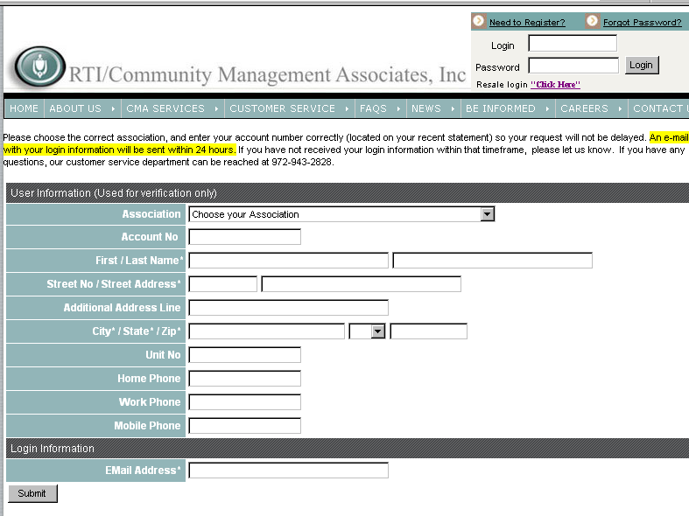
FIGURE 2

No dashes or spaces in acct #.

REGISTRATION SCREEN (FIGURE 2)

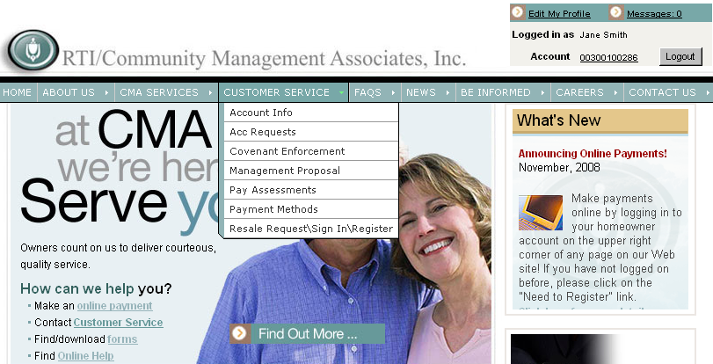

FIGURE 3

CUSTOMER SERVICE MENU (FIGURE 3)
Select Account Info to view your account ledger. You may also pay an unpaid balance from Account Info by clicking Pay Now. Select Pay Assessments to make a one- time payment or set up recurring payments by E-check or credit card. Select Payment Methods to read a description of all payment options.

How do I pay ONE TIME by e-check?
- Go to http://www.cmamanagement.com
- (Register)
- Log in with your Username (e-mail address) and Password. Remember they are case-sensitive.
- Click on CUSTOMER SERVICE, then PAY ASSESSMENTS.
- Choose ONE TIME PAYMENT.
- Click on ELECTRONIC CHECK (gray button).
- On the check payment screen, the address fields and CMA account # will be populated by the system.
- Select CHECKING or SAVINGS.
- Then enter your bank routing number and bank account number.
- Enter your payment amount and click CONTINUE
How do I set up RECURRING payments by e-check?
- Go to http://www.cmamanagement.com.
- Go to the top right and click on Log in.
- Log in with your User name(e-mail address) and Password.
- Click on CUSTOMER SERVICE, then select PAY ASSESSMENTS.
- Choose RECURRING PAYMENTS.
- On the Recurring Payments screen, the address fields and CMA account # will be automatically populated by the system.
- Select CHECKING or SAVINGS.
- Then enter your bank routing number and bank account number.
- Enter your payment amount.
- Choose frequency (monthly or quarterly).
- Then choose the day of the month you prefer your payment be deducted. We recommend the first of the month to avoid late charges.

A Note about Recurring Payments

If your assessments are due monthly or quarterly, then you may use the recurring payments screen. Please make sure you choose the correct frequency or you may be assessed late fees. If your billing is annual or semi-annual, please do not set up recurring payments as those options are not available at this time. Please refer to your statement for an amount due and the due date. If your assessment billing changes, you must go online and change the amount that you previously authorized to be deducted from your account to the current assessment amount.

Examples of assessment billing changes include a change in billing cycle, such as monthly to quarterly, an increase of assessments, any late fees, violation fines, or any other notice you may receive notifying you that you owe a different amount than what you had previously authorized.

Are any other owner services available on the CMA website?

Once you are a registered user, you may also select Covenant Enforcement (Violation) under the Customer Service menu to view violations if they are incurred for your property. You may also submit Architectural Control Committee requests and Resale Certificate requests online. Please contact our Customer Care Center if you need help in accessing these features.

Can CMA help me with home services?

CMA has partnered with WhiteFence, the leading online one-stop comparison shopping marketplace for consumers looking to compare and order essential home services. Through our CMA Website, (www.cmamanagement.com) you are connected with these services that power your life —from phones to high-speed Internet to electricity and beyond. This powerful transaction engine makes it easy for those who have moved or those who are just looking to switch services, to find the best deals and conveniently set up their home services in minutes.

KNOW WHO TO CALL WHEN YOU HAVE A CONCERN

Association Responsibility | City Responsibility
- Private Street maintenance, if applicable | - Public street maintenance including
 | curbs, drainage and traffic enforcement
- Parking of Vehicles as specified in CC&Rs | - Parking Enforcement on public thoroughfares including alleyways
- Common Area maintenance including gates | - Public parks and recreation areas
- Common Area signage | - Signage regulated by city ordinances
Political Signage on private property
- Common Area or other association- | - Public lighting, such as street lights
controlled lighting

- Architectural modifications to exterior  of owner properties as regulated by CC&Rs | - Issuance of building permits  When to obtain a permit
- Storage and placement of trash receptacles for collection by city or private contractors | - Trash collection if provided by municipal services
 | - Landscape watering rules
- American Flags of standard size may be | - Landscape watering rules
displayed, as protected by federal statute.
All other flags as regulated by CC&Rs. | - Neighbor disturbances
- Pets, if regulations are specified in CC&Rs | - Animal Control Services and matters regulated by city ordinances such as leash laws, noise/disturbing the peace and picking up pet waste
 | - Electric and watering in public parks
 | - Illegal business operations
 | - Health hazards

These are general guidelines that are typical of many owners’ associations. Please refer to your association’s
CC&Rs and your city’s website for regulations specific to your community.

DIRECTORY OF METROPLEX ATTRACTIONS AND MUNICIPAL SERVICES

Dallas/Ft. Worth Metroplex Attractions

Nearby Attractions
American Airlines Center 214.222.3687
Nokia Theater 972.647.5700
Reunion Arena 214.800.3080
Six Flags Over Texas 817.640.8900
Six Flags over Hurricane Harbor 817.265.3356
Texas Stadium 972.438.7676

Galleries - Museums
African American Museum 214.565.9026
Age of Stream Railroad Museum 214.428.0101
Amon Carter Museum 817.738.1933
Biblical Arts Center 214.691.4661
Dallas Museum of Art 214.922.1200
Dallas Museum of Natural Hist. 214.421.3466
Hall of State (Texas History) 214.421.4500
Kimbell Art Museum 817.654.1034
Modern Art Museum Ft. Worth 817.738.9215
Science Place 214.428.5555

Performing Arts
Bass Performance Hall 817.212.4280
Casa Manana Theater 817.332.2272
Dallas Black Dance Theater 214.871.2376
Dallas Theater Center 214.522.8499
Dallas Opera 214.443.1043
Dallas Symphony 214.871.4000
Morton H. Myerson Symphony Center 214.670.3600
Music Hall at Fair Park 214.565.1116
Plano Symphony Orchestra 972.473.7262
Smirnoff Music Centre 214.373.8000

Sporting Events
FC Dallas (outdoor Soccer) 214-705.6700
Dallas Cowboys (Football) 972.556.9900
Dallas Mavericks (Basketball) 214.747.6287
Dallas Stars (Hockey) 214.467.8277
Texas Rangers (Baseball) 817.273.5000
Frisco Rough Riders(Baseball) 972.731.9200
Mesquite Championship Rodeo 972.285.8777
Lone Star Park @ Grand Prairie 972.263.7223
Texas Motor Speedway 817.215.8500
Texas Motorplex 972.878.2641

Family Outings
Dallas Aquarium 214.670.8443
Dallas Arboretum
And Botanical Gardens 214.515.6500
Dallas Nature Center 972.296.1955
Dallas Zoo 214.670.5656
Fair Park 214.670.8400
Fort Worth Botanical Garden
And Conservatory 817.871.7686
Fort Worth Zoo and Mini Train 817.871.7050
Movie Studios at Las Colinas Tours 972.869.3456
McKinney Ave. Trolley 214.855.5267
Stockyards Museum History Society 817.625.5082
The Sixth Floor Museum 214.747.6660
Southfork Ranch Event and
Conference Center 972.442.7800
Tarantula Train 817.625.7245

Governmental Offices

Texas Department of Motor Vehicles
http://www.dmv.org/tx-texas/department-motor-vehicles.php

Voter Registration
http://www.sos.state.tx.us/elections/voter/index.shtml

Municipal Web Addresses

Addison
http://www.ci.addison.tx.us/

Allen
http://www.cityofallen.org/

Arlington
http://www.ci.arlington.tx.us/

Azle
http://azle.govoffice.com/

Bluffdale
http://www.granburychamber.com/

Burleson
http://www.burlesontx.com/

Carrollton
http://www.ci.carrollton.tx.us/

Cedar Hill
http://ci.cedarhill.tx.us:8080/

Directory Continued

Coppell
http://www.ci.coppell.tx.us/

Corinth
http://cityofcorinth.com/

Crowley
http://www.ci.crowley.tx.us/

Dallas
http://www.dallascvb.com/

Denton
http://www.co.denton.tx.us/

Euless
http://www.euless.org/

Fairview
http://www.fairviewtexas.org/

Farmers Branch
http://www.ci.farmers-branch.tx.us/

Flower Mound
http://www.flower-mound.com/

Fort Worth
http://www.fortworthgov.org/

Frisco
http://www.ci.frisco.tx.us/

Grand Prairie
http://gptx.org/

Grapevine
http://www.ci.grapevine.tx.us/

Hurst
http://www.ci.hurst.tx.us/

Irving
http://www.ci.irving.tx.us/

Keller
http://www.cityofkeller.com/

Lewisville
http://www.cityoflewisville.com/

Little Elm
http://littleelm.govoffice.com/

Mansfield
http://www.mansfield-tx.gov/

McKinney
http://www.mckinneytexas.org/frameset.asp?aid=144

Melissa
http://www.cityofmelissa.com/

Mesquite
http://www.cityofmesquite.com/

North Richland Hills
http://www.nrhtx.com/

Plano
http://www.plano.gov/

Red Oak
http://www.redoaktx.org/

Richardson
http://www.cor.net/homepage.html

Rockwall
http://www.rockwall.com/sitemap.asp

Rowlett
http://www.ci.rowlett.tx.us/rowlett/

Sachse
http://www.cityofsachse.com/

Seagoville
http://www.seagoville.us/

Southlake
http://www.ci.southlake.tx.us/

Terrell
http://www.cityofterrell.org/

The Colony
http://www.ci.the-colony.tx.us/

Wylie
http://www.ci.wylie.tx.us/

A NOTE FROM CMA
Dear Owner,
Each neighborhood possesses its own unique sense of place and aesthetic beauty, where landscaping and architectural controls are in place to ensure uniformity. Abiding by the standards described in this pamphlet will help to enhance your property, while complementing the community as a whole.
The community’s Covenants, Conditions and Restrictions (CC&R’s) set down standards to ensure that property values are not compromised or diluted. Structural design standards preserve the community’s appearance, while complying with the applicable building codes, fire codes and other laws and regulations.
This material is designed to guide individual owners in regard to specific standards for modifications, restrictions and architectural design. It provides instructions, timeframes and requirements for the application and review process.
The glossary of terms and frequently asked questions will familiarize you with your community’s requirements; however, this is an overview. Please refer to your association’s governing documents for full details.
Your CMA Management Team

GLOSSARY OF TERMS
ARC Committees & Forms – Architectural Review Committee. These named forms are to be used when submitting plans and applications for the construction or modification of improvements within the property.
Understanding your Community’s Standards:

Lakes of Coppell Owners Association, inc.

Association – This refers to the Owners Association in which each owner of record is a member of an existing Texas not-for-profit corporation.
CC & R’s – Covenants, Conditions, and Restrictions are established protective standards, restrictions, and obligations in areas ranging from architectural control to prohibitions on various activities in order to promote harmonious living.
Easement – Right granted by one property owner to another entity to allow access to a dedicated area.
Easement for Lakes – Such easement to extend ten (10) feet in width around the entire length of the Lake System for the maintenance and preservation of the Lake System and for the maintenance and repair of the concrete and wood walls and the stone paving lining the banks of the lakes.
Lake Set Back – No structure of any kind shall be placed or permitted to remain within twenty (20) feet of the bank of the lake within the Lake System.
Fine – A monetary charge issued to an owner’s account when the violation process has been exhausted in accordance with governing documents.
Inoperable Vehicle – Vehicle with flat tire(s), on blocks, expired registration and/or inspection stickers.
Property Owner – Developer, builder or owner of record who holds the recorded title to a piece of property or lot.
Self Help Notice – Notification to advise the owner that the Association will be taking necessary action at the expense of the owner in complying with a violation.
Survey Plat/Plot Plan – Certified drawing indicating the location of the home within the property lines, including the fence line boundaries.
Modification – Alteration, change, remodel, restoration, addition or renovation to any building, structure, fence, wall, landscaping or improvement project of any kind.
Violation – Non-compliance with the Community’s standards as dictated by the governing documents and guidelines, (i.e. not maintaining lawn or landscaping).
ARCHITECTURAL
MODIFICATIONS
Instructions: All changes made to the outside of your home must be submitted to the Architectural Review Committee prior to starting the project.
The form that should be used may be obtained by contacting CMA at 972-943-2850. Please remember that you may be very familiar with your project, however, the Committee is not. Submissions should include as much detail as possible, including colors, materials, drawings, plans, pictures, dimensions and all other information that will assist in the approval process. Also, you must include a plot plan/survey or your Lot indicating the specific site of the project.
Once this form is completed and all pertinent information is gathered, please send the entire submission to CMA.
REVIEW PROCESS: As stipulated in the CC&R’s, the Committee has up to 60 days from receipt of all required information to render a decision. The Committee may request additional information to help clarify the submission. After review, the Owner will be notified of the Committee’s decision.
APPLICATION: The Application should include photos, drawings, brochures, plats, colors, dimensions and any other information that will assist the Committee in their decision. Property Owners must sign the application. Contractor’s signatures for Property Owners will not be accepted without the Owner’s signature attached as well. Projects are not permitted to begin until the Committee has approved the application. Please note: the submission/application documents will not be returned to the Owners.
APPEAL: Owners may appeal the Committee’s decision by requesting a hearing in writing to the Management Company located at: 1800 Preston Park Blvd., Ste. 101, Plano, TX 75093.

ARCHITECTURAL
FAQs
- What projects need approval? Any modifications or alterations to the exterior of your property. Submission for approval is always recommended.
- Do I have to wait to start the project? Yes, all projects must be submitted and approved prior to starting.
- What if I did not obtain approval for my project? You will be asked to submit for approval. If your project is denied, you may be required to remove your project and restore the property to the previous condition.
- If my project will not change from the original design, location, color or dimension, do I need to submit to the Committee? Other than paint all improvements must be submitted to the committee review.
- My contractor does not provide drawings or brochures. What should I use instead? A hand drawing of the project will be sufficient as long as it includes a plat map, dimensions, colors and materials.
- Where can I obtain an ARC form? You can contact CMA and a form can be mailed, emailed, or faxed to you or you may download it online at www.cmacustomerservice.com.
- How will I be notified of the Committee’s decision? You will be notified by first class mail of the Committee’s decision.

RESIDENT FAQs
- Where can I get a copy of the Rules and Regulations for the Lakes of Coppell Association? Texas Property Code requires that all owners be given a copy of the Bylaws and Declaration for the property at closing. If you did not receive this information, contact your title company for your copy. If you have misplaced your copy, CMA will be happy to provide you with a copy for a fee.
- What are the lawn maintenance standards for the community? Section 14.01: Lot must be kept in a trimmed, well-kept and clean condition. Shrubs, trees and grass will be trimmed and free of trash and other unsightly materials. Weeds must be removed from lawn, flowerbeds and other planter areas on a regular basis.
- Can boats, trailers, or recreational vehicles be parked within the community? Section 9.02 (i): Recreational vehicles and trailers cannot be parked in the driveway or yard of a lot. They can, however, be parked in the garage if they are completely screened from view.
- Where should the trash receptacles be stored? Section 9.02 (i): Receptacles must be stored from public view at all times, with the exception of trash day.
- Can a commercial vehicle be parked on the property? Section 9.02 (i): Any vehicle other than conventional automobile is not allowed to be parked on a lot, unless it is stored from view in the garaged.

RESIDENT FAQs (cont’d)
- What are the Association requirements for a yard/garage sale? There is no Association restriction on garage sales. Check with the City of Coppell for city requirements.
- What are the restrictions for signage in the yard? Section 9.02 (i): One sign may be displayed listing a home for sale or rent. This sign cannot exceed 5 feet. One sign can be displayed for an open house (only during open house hours).
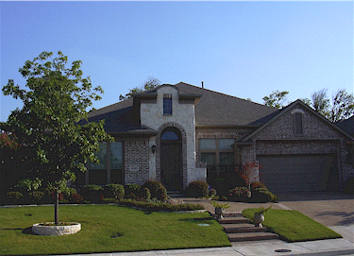
- If an Owner chooses not to abide by the Rules and Regulations, what are the consequences? Administrative Resolution No. 6: The Board of Directors may impose a fine, suspend voting rights, suspend use of the common areas or impose self-help to an owner.
Understanding your Community’s Standards:
________________________ Association
Tel: _____________________
Address
City, ST Zip
Enforcement Procedures
The existence of a violation will be verified by a field observation and an owner will be notified by mail (1st class and/or certified mail). The owner will have at least __ days to correct or eliminate the violation. Failure to correct the violation or request a hearing within the specified time will result in sanctions and or fines being imposed. Any attorney’s fees and costs will be charged to the owner’s account.

